**Application form**

**Participation at the UMSICHT Science Award**   
to promote industry-oriented environmental, process, and energy technology  
  
For uploading your application documents (max. 20 MB),   
please use [**s.fhg.de/science-award-201**](http://www.umsicht.fraunhofer.de/en/press-media/2015/science-award-2016.html)**9**

Please send audiovisual media that is hosted on a media platform via a link for download.

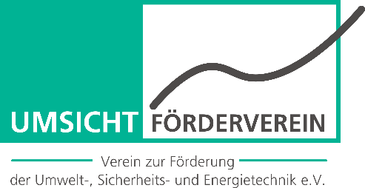

To submit until April 7, 2019

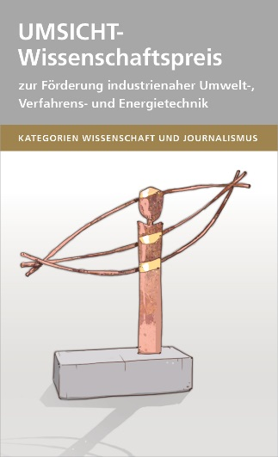

**Contact data** (please indicate one contact in case of a joint work.)

Surname / name:

Title:

Company:

Department:

Street:

Postal code / city:

Phone / fax:

E-Mail:     

**Title of the publication**

**Submission of the publication in category**



Science



Journalism

**Remarks**

**Curriculum Vitae**



Select and insert photo.

Education:

Career:

Publications:

Other:

**Application**

**For uploading your application documents (max. 20 MB) please use  
s.fhg.de/science-award-2019**

Please submit all your documents as PDF files. If your audiovisual media is hosted on a media platform (media library, vimeo, youtoube etc.) please send us the link for download. If this is not possible, please provide the media in a common format that can be duplicated.

Complete applications include:

* Application form (filled in and signed)
* Released science publication or journalistic publication
* A summary, if the publication comprises more than 10 pages (max. 3 DIN A4-pages)
* Motivation letter with the title „This ist he reason why I am engaged in research«   
  (max. one DIN A4-sized page)

There is no right of appeal. Intentional incorrect information leadsto an exclusion or to a deprivation of the award. The UMSICHT Friends and Patrons Group reserves its right only to evaluate completely submitted application documents and reserves its right to not endow the prizes.

**Notes on the data storage**

The data from your application will be saved electronically and is exclusively processed for the purpose of   
the selection and the granting of the UMSICHT Science Award. The data will not be passed on to third parties. The data of the candidates is deleated at the end of the subsequent year to the award ceremony at the latest. One exception is the data of the award winner. With the following declaration you approve to the procession of your personal data. Publications that receive an award will be published on the website of Fraunhofer UMSICHT as well as in press release and will be used for the promotion of further award competitions. Therefore, we kindly ask for your agreement, too.

**Statement of consent**

In the case that several people have been actively involved in the publication, I confirm that I have the consent of all parties concerned for applying. Furthermore, I can assure that I own the copyrights for the images and graphics used in this publication.

I agree to the storage and processing of my data within the scope of the UMSICHT Science Award. In the case that my publication will receive an award, I agree to the publication and provision of my application data for the website of Fraunhofer UMSICHT, a press release and a publication series of the UMSICHT Science Award. Furthermore, I agree that I will participate at the award ceremony in case of winning.

The date of the award ceremony is July 11, 2019.

Signature Place / Date

**Application deadline: APRIL 7, 2019**